­­



Submitted to

:

Sir.Safeeullah

Quiz # 1

***BS***

***-***

***Software Engineering***

***1***

***ST***

***-***

***E***

Title: Quiz # 1

English

Hamza Mehmood

NUML

-

S21

-

2352

9

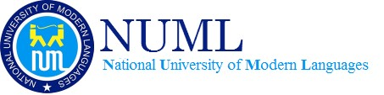

**National University of Modern Languages**

English Comprehension & Composition

# Submit 1 (15-4-2021)

Quiz-1 CLO-1 Total marks:20

Name: Hamza Mehmood Class Bs-Se

Roll No: SP21110

Q 1. Read the following sentences carefully and decide the type of underlined Pronoun,

1. All were drowned.

The Underline Word is **INDEFINITE PRONOUN**

1. I have last the book which my father gifted me.

The Underline Word is **RELATIVE PRONOUN**

1. Each of them was punished

The Underline Word is **DISTRIBUTIVE PRONOUN**

1. Which of the movies did you like most?

The Underline Word is **INTERROGATIVE PRONOUN**

1. Few escaped unhurt.

The Underline Word is **INDEFINITE PRONOUN**

Q 2. Read the following sentences and decide the type of underlined adjective.

I have a black pen.

The underline word is **(Descriptive)**

She has two daughters.

The underline word is **(QUANTITY)**

My brother got first division.

The underline word is **(ORDINAL NUMERAL)**

What manners of man is he?

The underline word is **(INTERROGATIVE)**

Each boy was punished.

The underline word is **(DISTRIBUTIVE)**